Project Design Phase-I Solution Architecture

|  |  |
| --- | --- |
| Date | 27 October 2022 |
| Team ID | PNT2022TMID31070 |
| Project Name | Project – Fertilizer Recommendation System For Disease Prediction |
| Maximum Marks | 4 Marks |

# PROBLEM DISCRIPTION:

Agriculture is the most important sector in today’s life. Most plants are affected by a wide variety of bacterial and fungal diseases. Diseases on plants placed a major constraint on the production and a major threat to food security. Hence, early and accurate identification of plant diseases is essential to ensure high quantity and best quality. In recent years, the number of diseases on plants and the degree of harm caused has increased due to the variation in pathogen varieties, changes in cultivation methods, and inadequate plant protection techniques.

An automated system is introduced to identify different diseases on plants by checking the symptoms shown on the leaves of the plant. Deep learning techniques are used to identify the diseases and suggest the precautions that can be taken for those diseases.

# CHARACTERISTICS:

A fertilizer recommendation is the research-based set of guidelines, or management practices, for supplying fertilizer to the crop to achieve yield and quality goals (economic) in a manner that minimizes nutrient losses to the environment.

# SOLUTION ARCHITECTURE:

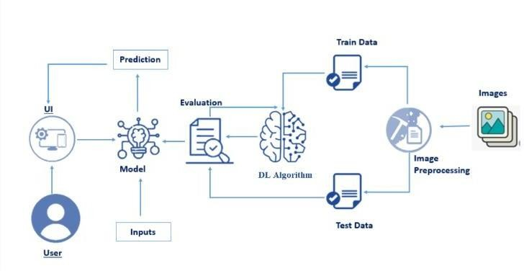

**DEVELOPMENT PHASE**:

1. **DATA COLLECTION:**

Data collection is the most efficient method for collecting and measure the data from different resources like kaggle and UCI machine learning repository. To get an approximate dataset for the system. This dataset must contain the following attributes i.) Images of fruit diseases ii.) Images of vegetable diseases etc., in which those parameters will consider for disease prediction.

1. **DATA PRE-PROCESSING**:

After collecting datasets from various resources. Dataset must be pre-processing before training to the model. The data pre-processing can be done by various stages, begins with reading the collected dataset the process continues to data cleaning. In data cleaning the datasets contain some redundant attributes, those attributes are not considering for disease prediction. So, we have to drop unwanted attributes and datasets containing some missing values we need to drop these missing values or fill with unwanted values in order to get better accuracy. Then define the target for a model. After data cleaning the dataset will be split into training and test set by using specific libraries.

1. **DEEP LEARNING ALGORITHM FOR PREDICTION:**

Machine learning predictive algorithms has highly optimized estimation has to be likely outcome based on trained data. Predictive analytics is the use of data, statistical algorithms and machine learning techniques to identify the likelihood of future outcomes based on historical data.

1. **FERTILIZER RECOMMENDATION:**

To Predict the particular fertilizer to be used, we use input parameters like N,P,K temperature, humidity, moisture and soil type and also crop to be grown. Fertilizer prediction process being with the loading the external fertilizers datasets. Once the dataset read then pre-processing will be done by various stages as discussed in Data Pre-processing section. After the data pre-processing, train the models using SVM, Random Forest classifier into training dataset. For a prediction of the fertilizers, we consider a various factor such as temperature, humidity, soil PH and predicted crop to be grown. Those are the input parameter for a system that can be entered by manually or taken from the sensors. Predicted crop and input parameter values will be appended in a list

# RESULT:

The proposed system recommends the best suitable fertilizer for particular land by considering parameters such as various historical image data’s. Among these parameters the crop disease is predicted by system itself by using previous data with SVM algorithm and other parameters are have to be entered by the user. In the output section the system displays a suitable fertilizer and various suggestions based on the severity level of the diseases.